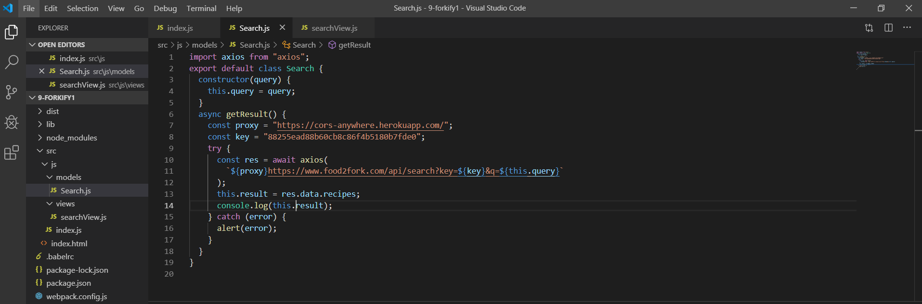

Export ra class

Trong class chứa query và method getResult which is API call function

We use axios again so we also need import axios statement

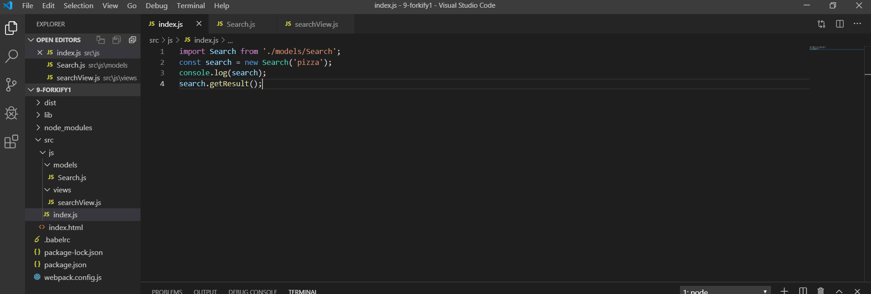

Remember that class and object is use the same way, it store in background the same way

So we create and use it like an object that we learn before